ROSE · PULSE — Figma Design Tokens & Auto Layout Component Library
Group GP6 Design System Reference · WCAG 2.1 AA/AAA Contrast · 1440×900 12-Column Grid · Synchronized with CSS Tokens
This manual specifies the foundational design tokens, typographic scale, 1440×900 Auto Layout spatial rules, and reusable component library governing all 62 vector artboards in ROSE_Figma_HiFi_UI_GP6.zip and rose-design-tokens-and-components.css.

1. Semantic Color Tokens & Verified WCAG 2.1 Contrast Ratios
To replace sterile hospital blues with a welcoming Malaysian community health identity while guaranteeing readability for older adults with early cataract or presbyopia, ROSE · PULSE pairs Deep Forest Green (#153B30) and Warm Cream (#FAF8F4) surfaces with high-contrast text tokens.
CSS / Figma Token | Hex Value | Paired Surface | Contrast Ratio | Semantic UI Role
--rp-color-forest-900 | #153B30 | #FAF8F4 Text | 11.9 : 1 (AAA) | Full-height 220px left navigation sidebar & primary brand header
--rp-color-emerald-600 | #1F6F50 | #FFFFFF Text | 6.1 : 1 (AA+) | Primary CTA buttons, active category pills, and input focus rings
--rp-color-gold-400 | #DFB982 | #18241E Text | 9.6 : 1 (AAA) | Active sidebar navigation pill and hero 'Browse events' CTA
--rp-bg-canvas | #FAF8F4 | #1F2937 Text | 13.6 : 1 (AAA) | Warm low-glare portal background canvas across all 62 artboards
--rp-bg-surface | #FFFFFF | #1F2937 Text | 14.2 : 1 (AAA) | Elevated event cards, form containers, and modal dialogs
--rp-color-amber-100 | #FDF6E7 | #8A5A10 Text | 5.8 : 1 (AA) | Pending / Awaiting review status badges and waitlist notices
--rp-color-coral-100 | #FDF2EE | #9A3412 Text | 7.3 : 1 (AAA) | Non-destructive field validation and duplicate MyKad alerts

2. Modular Typography Scale & Bilingual (EN / BM) Expansion Rules
Bahasa Melayu phrases expand horizontal label length by 18–28% compared to English (for example, 'Manage Registrations' -> 'Urus Pendaftaran', 'Apply as Guest' -> 'Mohon sebagai Tetamu'). All Figma Auto Layout frames use Hug Contents or flexible fractional widths with generous horizontal padding so labels never clip.
Type Token | Size / Weight | Line Height | Primary Component Usage
--rp-text-2xl (Hero) | 30px / 800 ExtraBold | 1.20 (36px) | Scenic hero banner headline (P-01 EN & P-02 BM)
--rp-text-xl (Section) | 22px / 800 ExtraBold | 1.25 (28px) | Page headers ('Search Results for Screening', 'Upcoming events')
--rp-text-lg (Card Title) | 18px / 700 Bold | 1.30 (24px) | Event card titles, modal titles, and lightbox headers
--rp-text-base (CTA) | 15px / 700 Bold | 1.40 (21px) | Primary 48px form submission buttons and receipt banners
--rp-text-sm (Body/Input) | 13.5px / 500–600 | 1.45 (20px) | Sidebar links, 42px form inputs, and registration table rows
--rp-text-xs (Badge/Pill) | 11.5–12px / 700 Bold | 1.35 (16px) | Segmented EN|BM pill, status badges, and quota counters

3. 1440×900 Pure Web Grid & Figma Auto Layout Specification
Layout Region | Dimensions (px) | Figma Auto Layout Mode | Padding & Gap Tokens
Root Desktop Frame | 1440 × 900 | Horizontal (Fixed 220px + Fill 1220px) | 0px outer margin · clip content enabled
Role-Scoped Sidebar | 220 × 900 | Vertical · Space-Between | Padding 20px 16px · Nav item gap 8px · Radius 10px
Main Content Canvas | 1164 × 780 | Vertical · Top-Aligned | Left/Right gutter 28px (x=248 to x=1412) · Section gap 20px
3-Card Event Grid | 3 × (372 × 318) | Horizontal · 3 Equal Columns | Column gap 24px · Card internal padding 10px–18px · Radius 16px
Split Detail + Form | 520 Left + 622 Right | Horizontal · 2 Asymmetric Panes | Pane gap 22px · Form 2-column field grid (270px + 270px, gap 24px)

4. Reusable Component Library & Interactive State Variants
Component Name | CSS Class | Interactive Variants | Accessibility & Touch Target Spec
Bilingual Switcher Pill | .rp-lang-switcher | EN Active | BM Active | Hover | 96×36px pill at (x=1146, y=66); aria-pressed state & ?lang= sync
Header Search Input | .rp-search-bar | Default | Focused (P-01S) | Filtered | 396×38px rounded bar with 24×24px clear button (✕) & Enter submit
Event Summary Card | .rp-event-card | Default | Selected | Waitlist Full | 372×318px (482px in P-01S); 36–40px full-width emerald CTA button
Guest Mode Toggle Bar | .rp-guest-mode-banner | Guest Active | Sign-Up Prompt | 564×44px banner confirming zero account required before typing
6-Field Input Control | .rp-input | Empty | Filled | Focus | Error | 42px height; preserves user values on 422 duplicate MyKad check
Doc Thumbnail & Lightbox | .rp-doc-thumb / .rp-lightbox-modal | Inline Row Chip -> 150% Modal | 44px clickable chip opening 1120px high-contrast clinical preview

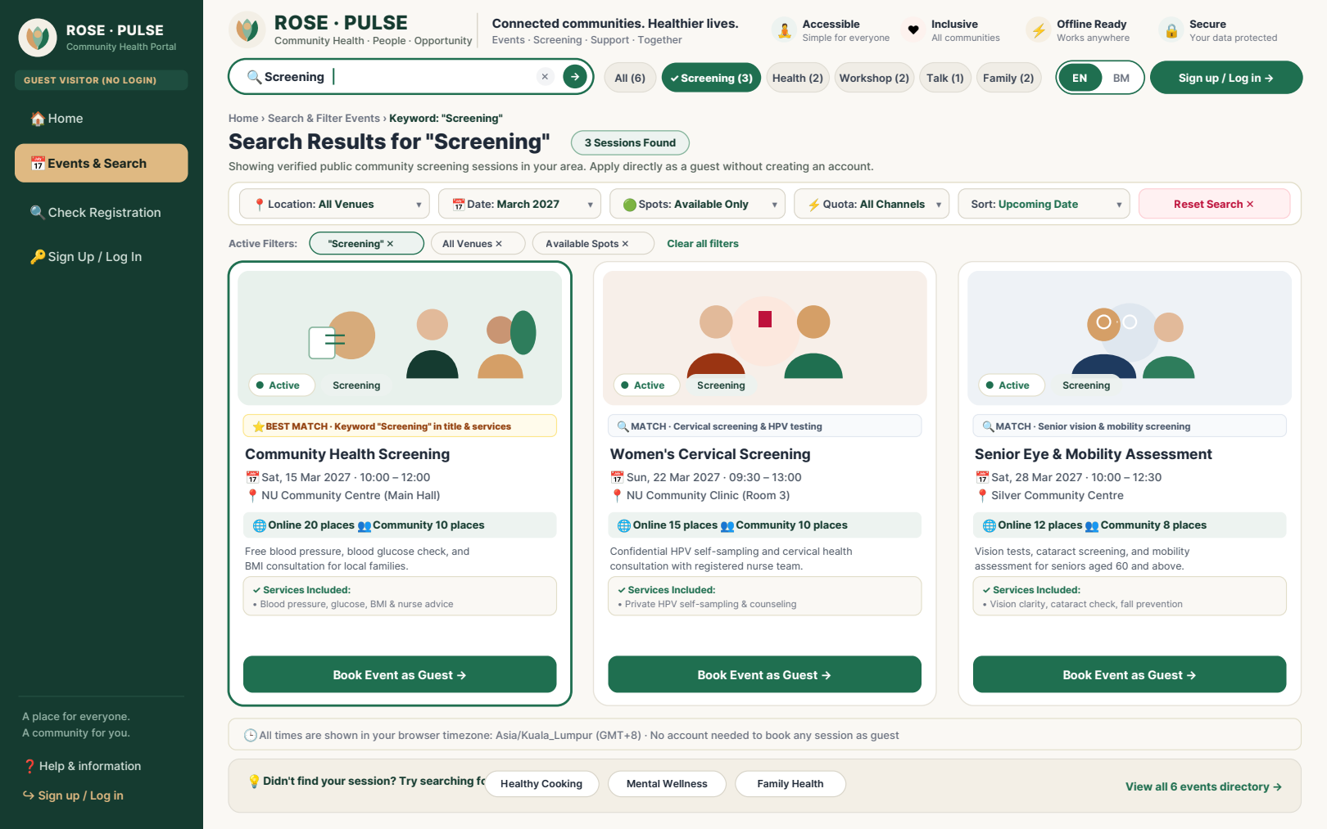
Figure 1: Component Library in Action on Artboard P-01S — Focused .rp-search-bar, .rp-cat-pill--active, Multi-Facet Filter Bar, and 3-Column .rp-event-card Grid.

